Chapter 14, Solution 63.

For an active highpass filter,

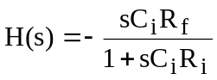 (1)

But
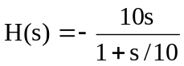 (2)

Comparing (1) and (2) leads to:

